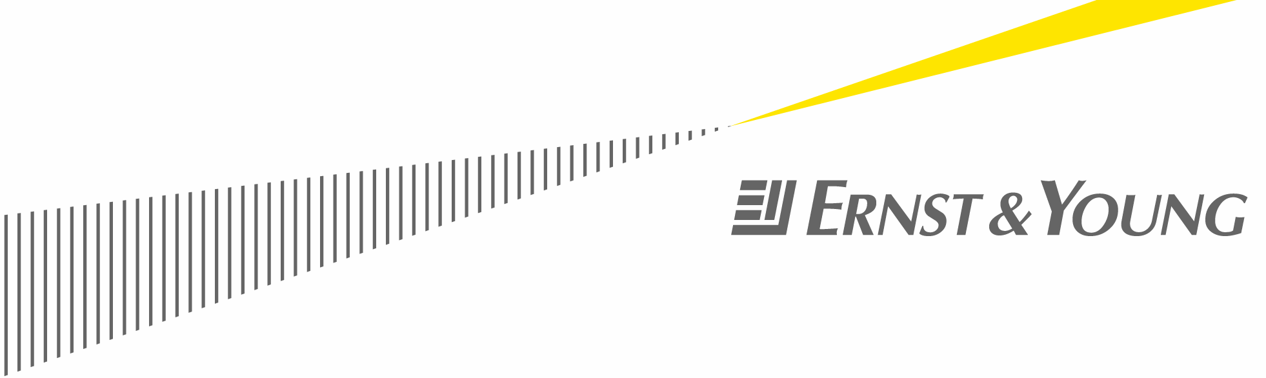

June 2, 2010

FDI projects down 11% in 2009 in Europe
Flight to investment safety with larger Western European markets holding up
Paris and London, 2 June 2010: Ernst & Young’s 5th Annual European Attractiveness Survey released today at the World Investment Conference in La Baule in France revealed some stark contrasts in terms of inward investment projects announced across Europe in 2009.
Overall, despite the deep recession, Europe remained in business securing 3,303 investment projects; a modest 11% decline in project numbers. At a country level, there were some very mixed results.
Marc Lhermitte, Ernst & Young partner and the author of the report explains, “Investors, whether internally within Europe or externally from the US and the Far East, have focused on proven markets with scale. Central and Eastern Europe, generally, and many of the smaller countries in Western Europe have seen dramatic drops in project numbers as investors have flown to the safety of bigger, safer economies like the UK, France and Germany.“
Investment by sector: a contrasted landscape
In general terms sectors that require heavy investment or that have traditionally gone to Central and Eastern Europe suffered in 2009 as did those that were more associated with an expanding economy. Automotive, mining and transport projects were all significantly down while business services and software projects also took a hit.
However other sectors – perhaps those that more recession proof – food, pharmaceuticals and electrical all showed growth in terms of project numbers.
Where the investment is going to: Winners and losers
The big European economies held up relatively well in terms of their ability to attract inward investment in 2009. Projects numbers in the UK were only down 1%, while those in France, Italy and Germany were up 1%, 4% and 7% respectively.
There were some other winners in terms of investment projects. Russia, Ukraine and Turkey bucked the trend of their neighbours in Eastern Europe by all posting increases in the number of projects in 2009.
Understandably with a 4% decline in European GDP there were some big losers in 2009 as well. The Spanish and Irish economies that historically have had particular appeal to investors outside Europe were hit particularly hard in 2009 and it was not surprising their project numbers were down. However where the impact of the recession was most dramatic was in countries like Poland, Hungary, Romania and the Czech Republic where project numbers fell collectively by 40% as investors sought the stability of the larger Western economies.
Where the investment is coming from: the new clients of Europe
There was also a mixed picture in terms of where projects originated. The United States, which continues to account for roughly a quarter of all projects into Europe saw a decline in absolute and relative terms as did Germany, the UK, France and Japan who combined make up another 25% of the investment numbers.
There were some countries who did invest more in Europe in 2009 than 2008 notably China whose project numbers increased by nearly 30% from 87 to 111. Chinese projects were also responsible for the third largest numbers of jobs created across Europe in 2009.

A modest improvement for 2010?
As well as analyzing project data for 2009 the European Attractiveness Survey looks at investment outlook by asking over 800 executive their future intentions.
Although a high percentage of those asked (53%) said they would be likely to sit on their hands a while longer before committing to further investment in Europe, Lhermitte explains the investment environment is showing signs of improvement from 12 months ago.

“We saw a definite acceleration in the fourth quarter of 2009 in project announcements as investors became more confident. The current problems around the Euro not withstanding we expect that 2010 overall will show a modest pickup in project numbers and at least a flat lining in job creation numbers.”

Where next for Europe in terms of global attractiveness?
While investors still perceive Western Europe as an attractive region (38%) to do business in, just behind China (39%), they have concerns about Central and Eastern Europe which ranked second globally in 2009. This year the region saw its attractiveness rating decline from 42% to 24%.
Longer-term however investors continue to see Central & Eastern Europe as a priority: The region is perceived as the third most attractive location over the next three years by 59% of investors, just behind China (66%) and India (61%).
Jay Nibbe, Deputy Area Managing Partner for Ernst Young in EMEIA said, “As our own Eurozone Economic Forecast recently predicted GDP growth across Europe will struggle to reach 1% in 2010 and even in the medium term growth will be a pale shadow of that in the US and in developing markets across the world.”
Nibbe adds, “European governments have to put the challenge of remaining attractive to existing and new business to the top of their agenda and start thinking about the practical actions they can take to encourage enterprise and investment. Without concrete and real action Europe will face an even harder task to ensure sustainable and substantial economic growth.”
ends
About the survey:
The Ernst & Young’s European attractiveness 2010 survey is based on a twofold, original methodology that reflects:
• The “real” attractiveness of Europe for foreign investors. Our evaluation of the reality of FDI in Europe is based on Ernst & Young’s EIM. This unique database tracks FDI projects that have resulted in new facilities and/or the creation of new jobs. By excluding portfolio investments, mergers and acquisitions, it shows the reality of investment in manufacturing or services operations by foreign companies across the continent.
• The “perceived” attractiveness of Europe and its competitors by foreign investors. We define the attractiveness of a location as a combination of image, investors’ confidence and the perception of a country or area’s ability to provide the most competitive benefits for FDI. The field research was conducted by Institut CSA in January and February 2010, via telephone interviews, based on a representative panel of 814 international decision-makers.
About Ernst & Young
Ernst & Young is a global leader in assurance, tax, transaction and advisory services. Worldwide, our 144,000 people are united by our shared values and an unwavering commitment to quality. We make a difference by helping our people, our clients and our wider communities achieve their potential.
Ernst & Young refers to the global organization of member firms of Ernst & Young Global Limited, each of which is a separate legal entity. Ernst & Young Global Limited, a UK company limited by guarantee, does not provide services to clients. For more information about our organization, please visit www.ey.com
This news release has been issued by EYGM Limited, a member of the global Ernst & Young organization that also does not provide any services to clients.

